BIG SPRINGS PARK
Maryville, Tennessee

January 28, 1991

Design Guidelines,
Declaration of Covenants,
Conditions & Restrictions

Prepared for:



Sterling Engineering, Inc.
Civil Engineers/Project Managers

J. R. Wauford & Company
Utility Engineers

Bullock, Smith and Partners, Inc.
Architects/Planners

TABLE OF CONTENTS

PAGE
I. DEFINITION OF TERMS 2
II. PURPOSE OF THIS DECLARATION 3
- PERMITTED LAND USES 3
- DESIGN REVIEW COMMITTEE 4
- PRIOR APPROVAL BY COMMITTEE OF ALL 4
PLANS FOR ALL REAL IMPROVEMENTS
- PERMITTED REAL IMPROVEMENTS 6
- RESOLUTION OF COMPLAINTS AS TO 6
VIOLATIONS OF THIS DECLARATION
- CONFLICTS 7
- EASEMENTS RESERVED 8
- DURATION, MODIFICATION AND TERMINATION 8
- ENFORCEMENT 9
- LIENS CREATED IN AID OF ENFORCEMENT 10
OF DECLARATION
- PROVISIONS FOR RE-SUBDIVISION .AND 10
RECAPTURE
XIV. SEVERABILITY 11
XV EXHIBIT A: DESIGN GUIDELINES 11
MASTER PLAN (Illustration) 16
DECLARATION OF COVENANTS, CONDITIONS, RESTRICTIONS AND DESIGN GUIDELINES APPLICABLE TO BIG SPRINGS PARK
ADOPTED BY THE BOARD OF COUNTY COMMISSIONERS OF BLOUNT COUNTY, TENNESSEE
AND THE CITY COUNCIL OF THE CITY OF MARYVILLE, TENNESSEE
THIS DECLARATION, made this the 28^{T}" day of January, 1991 by the Board of County Commissioners of Blount County, Tennessee, (acting through the Blount County Executive), and the City Council of the City of Maryville, Tennessee, (acting through the Mayor of the City of Maryville), hereinafter referred to as •Declarants" :

WITNESSETH:
WHEREAS, Declarants are the owners of the 268.9 acre tract, (of which approximately 230 acres are free of highway easements, drainage easements, etc.). described by metes and bounds in the deeds from Ross, Yearout, Beirne, Mohler, Mantooth, and Bagwell to Blount County, Tennessee and the City of Maryville, Tennessee, said deeds being of record in Book of Deeds Vol. 498, page 658, Vol. 498, page 664, Vol. 498, page 666, Vol. 498, page 668, Vol. 501, page 664, TR. 1, and Vol. 501, page 664, TR. 2, in the Register's Office for said County; said tract of land being known and designated herein as Big Springs Park ('BSP');
WHEREAS, Declarants are desirous of subjecting said real property to the conditions, covenants, restrictions, easements, reservations and design guidelines hereinafter set forth, each and all of which is and are for the benefit of said property and for each Owner and Occupant of any part thereof;
NOW, THEREFORE, Declarants hereby declare that said real property is and shall be held, transferred, sold, conveyed, leased, subleased and occupied subject to the conditions, covenants, restrictions, easements, reservations, and design guidelines hereinafter set forth.
I. DEFINITION OP TERMS.
The following terms and words are defined for use herein as follows:
(a) Building Site - shall mean a tract of real property within Big Springs Park (BSP) which is not a part of Public Areas (as hereinafter defined).
(b) Real Improvements - shall mean and include,
but not be limited to, buildings, out buildings, roads, driveways, parking areas, fences, screening walls, retaining walls, loading areas, signs, utilities, lawns, removal and planting of trees, landscaping and walkways, site grading, together with any other construction, work or treatment done or applied to a Building Site in connection therewith.
- Owner - shall mean an entity, whether it be
an individual, corporation, joint venture, partnership or
association, which is the record owner of a legally recognizable
interest in a Building Site.
- Occupant - shall mean an entity, whether it
be an individual, corporation, joint venture, partnership or
association, which has purchased, leased, rented or has otherwise
legally acquired the right to occupy and use any Building Site, or
portion thereof.
- Declaration - shall mean this Declaration of
Covenants, Conditions, Restrictions, and Design Guidelines,
together with all of the provisions contained herein as they now
appear and as they may be hereafter amended.
i,
- Design Review Committee - shall mean the
Committee established by Section IV hereof.
- Design Guidelines - shall mean the Design
Guidelines which are attached hereto and marked Exhibit A and
identified as such by the certificate of the County Executive and the Mayor on the last page thereof.
(h) Public Areas - shall mean those areas dedicated to public streets, storm water detention basins, greenways, and any other areas for use by the general public and which are jointly or separately owned by the City of Maryville and Blount County.
(i) Blount County Industrial Development Board
(IDB) — shall mean that organization duly constituted on behalf of the City of Maryville and Blount County Tennessee.
II. PURPOSE OF THIS DECLARATION.
This declaration is made to insure proper use, development and improvement of Big Springs Park, so as to: (1) protect the Owners and Occupants of Building Sites against such use of neighboring Building Sites as might depreciate the value of their property; (2) guard against the erection in BSP of structures built with unsuitable materials or of improper quality; (3) insure adequate and reasonable development of BSP; (4} encourage the erection of attractive, permanent improvements appropriately located to insure harmonious appearances and functions; and (5) encourage compatible, architectural and engineering design and, in general, provide a harmonious development that will promote the general welfare of the Owners and Occupants of BSP.
III. PERMITTED LAND USES.
Unless otherwise approved by the Design Review Committee, Building Sites within BSP shall be used only "for the manufacturing, processing, creating and or assembly of goods, merchandise and equipment; warehousing and distribution; and offices for research and services not necessarily related to manufacturing or industrial uses; and only in accordance with the provisions of the Design Guidelines as reasonably interpreted by
the Design Review Committee. The Design Review Committee shall determine, (subject to appeal to the full IDB), whether or not any present or intended use of a Building Site by an Owner or Occupant is within the meaning and intent of the aforesaid uses and whether same is in keeping with the purposes referred to in Section II herein.
IV. DESIGN REVIEW COMMITTEE.
There is hereby established the Design Review Committee, hereafter referred to as the 'Committee' which shall consist of no more than six (6) members, of which 3 shall be appointed by the City of Maryville and 3 by the Blount County Industrial Development Board (IDB). The purpose of the Committee shall be to: (1) review plans for compliance with the provisions of the Design Guidelines and intent of this Declaration, and (2) rule upon the question of uses which may be permitted after such approval and (3) other duties as may be required by the provisions
of this Declaration.

¹
V. PRIOR APPROVAL BY COMMITTEE OF ALL PLANS FOR ALL REAL IMPROVEMENTS
Prior to the beginning of any construction of or exterior alteration of any Real Improvement (as defined herein above) on any Building Site, the plans and specifications for such construction or alteration must have received the written approval of the Design Review Committee. Said Committee shall either approve, (with or without conditions), or disapprove plans and specifications submitted to it within thirty (30) days from the date on which they are submitted, and failure to either so approve or disapprove within this period shall constitute approval of said plans. The Committee shall determine the adequacy" of the plans and specifications, may deny approval if the plans and specifications are deemed insufficient.
.
Not withstanding other municipal requirements,
codes and ordinances, and upon receipt of such approval, the Owner and Occupant to whom such approval is given shall, as soon as
4
practicable, satisfy any conditions thereof and diligently proceed with the commencement and completion of all approved construction. If work on the approved construction is not commenced and diligently pursued within the time specified by the Committee, then such approval is subject to revocation, but the Committee or the IDB may grant an extension of time (in writing) for commencing and/or proceeding with said work.
/Any Owner or Occupant u/ho has received an adverse
ruling on any matter before the Committee may appeal such ruling to the IDB. Actions of the IDB on appeals from the Committee relating to approval or disapproval of plans, specifications and/or other matters submitted to it pursuant to the provisions of this Section V, or in respect of any other matter before it, shall be conclusive and binding on all parties.
All communications to the Committee shall be addressed as follows:

BSP Design Review Committee
c/o The Industrial Development Board
of Blount County, Tennessee

309 S. Washington Street Maryville, Tennessee 37801
ATTENTION: Executive Vice President
-
or to any such address as the Committee shall hereafter designate in writing addressed to all known Owners and Occupants, sent by certified or registered mail to their last known addresses.

Applications for approval of plans and
specifications hereunder are to be submitted in duplicate. The Committee's responses to such applications shall be in writing.
Neither the Committee, the IDB, nor any member,
employee or agent thereof shall be liable to any Owner or Occupant or to anyone submitting plans for approval, or to any other party, by reason of a mistake in judgment, negligence or non-feasance,
arising out of or in connection with the approval, disapproval or failure to approve any such plans, or for any other action in connection with said submission. Any Owner or Occupant who submits plans for approval thereby agrees to make no claim, nor bring any action for any alleged damages, against the Committee, the IDB, nor any member, employee or agent of the Committee or the IDB.
Governmental entities may also require submission of site plans or other documents for approval. In instances of conflict the more restrictive requirements shall apply.
VI. PERMITTED REAL IMPROVEMENTS.
The Design Guidelines, (attached hereto as
Exhibit A) , are hereby established as the guiding principles to be observed by the Design Review Committee, and shall be adhered to by said Committee except where, by reason of special circumstances, it appears that (1) to so adhere would cause unusual hardship on the Owner, and that (2) to grant a variance (a) would cause no harm to other Owners and (b) would not do violence to the purpose set forth in Section II hereof; provided, however, in order for a variance to be granted, the Committee must approve the same, and the IDB must affirmatively ratify the action of the Committee granting the deviation from said Guidelines, said ratification to be in the form of a motion duly approved by the IDB at a duly called meeting thereof.
In no instance, however, shall the Committee waive any requirements of the City or County which are more stringent than the Design Guidelines.
VII. RESOLUTION OF COMPLAINTS AS TO VIOLATIONS OF THIS DECLARATION
Each Owner and Occupant shall be entitled to file one or more complaints with Design Review Committee alleging one or more violations of this Declaration. Said Committee shall designate one (1) of its members or an agent who shall be readily
6
available to investigate any complaints filed, if such member or agent shall conclude that any complaint filed has merit, the alleged violator shall be promptly notified in writing of the complaint and of the ruling of said member or agent on behalf of the Committee; and, upon receipt thereof, the alleged violator shall have five (5) business days within which to begin, in good faith, to cure the violation or within which to file an appeal to the IDB. If the alleged violator does not begin in good faith to cure the violation or file a written appeal to the IDB within 'the five (5) days provided, said member or agent may, (but shall not be required to), cause the violation to be cured at the expense of the Owner or Occupant deemed to be in violation. If the alleged violator appeals to the IDB, the IDB at a duly convened meeting shall hear the appeal and act thereon within not more than thirty (30) days. If, in ruling on the appeal, the IDB agrees that there is a violation, the IDB may cause the violation to be cured, at the expense of the Owner or Occupant in violation, if the violator has not cured such violation within a reasonable time as determined by the IDB.
By purchasing or leasing property subject to this Declaration, each Owner or Occupant binds itself, its successors and assigns, to pay the Committee the actual cost to cure any violation hereunder together with liquidated damages of ten percent (10%) of such cost, which damages are, u/hen collected, to be allocated by the Committee toward defraying the cost of enforcing this provision.
VIII. CONFLICTS.
Zoning restrictions and regulations, applicable building and inspection codes and regulations, and all other applicable governmental restrictions and requirements shall be observed. In the event of any conflict between this Declaration and any such governmental codes, regulations, restrictions or requirements, the provisions which are more restrictive shall apply.
IX. EASEMENTS RESERVED.
Permanent easements for the installation and maintenance of underground utilities, supply and transmission lines, and drainage facilities are hereby reserved throughout BSP, but only on those areas on which no buildings or other similar type improvements are permitted under the Design Guidelines. Such easements shall include the right of ingress and egress, provided that any damage to property or improvements thereon resulting from the installation, maintenance or repair of any underground utilities, supply or transmission lines, or drainage facilities . shall be repaired or replaced at the expense of the authority which directed the activities causing the damage.
X. DURATION, MODIFICATION AND TERMINATION.
The conditions, covenants, restrictions,
easements, and reservations set forth in this Declaration shall run with and bind the land within BSP, as well as any adjoining real property to which this Declaration is extended, and shall be and remain in effect, and shall inure to the benefit of, and be enforceable by the Declarants, the IDB, or the Owner of any property subject to this Declaration, their respective legal representatives, heirs, successors and assigns for a terra, of twenty-five (25) years from the date this Declaration is recorded, except that any easement created hereby shall exist to the extent permitted by law.
The terms of this Declaration may be modified from time to time in accordance with the following provisions:
(a) So long as Declarants own two-thirds (2/3)
or more of the total acreage of BSP in Building Sites, Declarants shall have the right to amend any of the terms of this Declaration with the approval of one-half (1/2), (by number, without regard to acreage owned), of the Owners of "other Building Sites in BSP.
8
(b) If and when Declarants own less than two-thirds (2/3), but own at least ten percent (10%) of the total acreage of BSP in Building Sites, the terms of this Declaration may be amended by Declarant with the approval of two-thirds (2/3), (by number, without regard to acreage owned), of the Owners of Building Sites in BSP.
(c) If and when Declarants cease to own any part of BSP, the terms of this Declaration may be amended by the affirmative vote of three-fourths (3/4) of the BSP Owners and Occupants, said action shall be on the basis of one vote per acre, (or major fraction thereof), owned.
All such amendments must be promptly confirmed in writing(s) signed by Declarants and/or by the requisite number of Owners and copies must be furnished to all Owners and Occupants, and a duly executed and acknowledged copy must be filed in the Register's Office for Blount County, and must be recorded at least thirty (30) days prior to the effective date thereof.
•
Each purchaser, lessee or grantee of any interest in any real property now or hereafter made subject to this Declaration, by acceptance of a deed, lease, or other conveyance thereof, thereby agrees that the conditions, covenants, restrictions, easements, and reservations of this Declaration may be amended, terminated, shortened or extended as provided above.
XI. ENFORCEMENT.
Enforcement of the provisions of this Declaration shall be any appropriate proceeding at law or in equity against any person, corporation or other entity violating or attempting to violate said provisions, either to restrain such violation, to enforce personal liability, or to recover damages, or by any appropriate proceeding at law or in equity against the land to enforce any lien or charge arising by virtue hereof. The failure of the Declarants, or any Owner or Occupant to enforce any of the
provisions of this Declaration shall in no event be deemed a u/aiver of the right to do so thereafter. Every Owner or Occupant shall be obligated to pay the attorney's fees of the party or parties bringing an action against each Owner or Occupant for the enforcement of the provisions of this Declaration, provided such party or parties bringing said action has obtained a judgment in its favor by a court of record and such judgment has become final. The amount of attorney's fees shall be determined by the court involved in such proceedings.
XII. LIENS CREATED IN AID OF ENFORCEMENT OF DECLARATION.
Any monetary obligation created, authorized, or imposed on any Owner or Occupant hereunder, if not paid u/ithin thirty (30) days of due date shall be secured by a lien on Owner's property upon the filing in the Register's Office for Blount County, Tennessee, of a Notice of Lien which details the nature and amount of the obligation, the date due, and the fact of nonpayment, duly sworn to and acknowledged before a Notary Public by an officer of the IDB and/or the BSP Owners and Occupants Association established herein; said lien shall be inferior to all duly perfected and recorded pre-existing liens, but shall be superior to all subsequently recorded liens, excepting only liens for ad valorem realty taxes.
XIII. PROVISIONS FOR RE-SUBDIVISION AND RECAPTURE Re-subdivision: Re-subdivision of property within BSP by Owners other than the Declarants shall not be allowed without approval of the IDB.
Recapture: If, after the expiration of one (1) year from the date of execution of a sales contract agreement on any Building Site within BSP, any purchaser shall not have begun in good faith the construction of any acceptable building, the IDB retains the option to refund the original purchase price and repurchase the property. At any time, the IDB may extend in
10
writing the time within which such building construction may started.
XIV. SEVERABILITY.
Invalidation of any one or more of the provisions of this Declaration by judgement or court order shall in no way affect any of the other provisions which shall remain in full force and effect.
XV. APPENDIX A: DESIGN GUIDELINES
The following Design Guidelines are established for use by the Design Review Committee to achieve the purpose of Section II of the Declaration.
(a) Permitted Uses: In addition to those uses stipulated in Section III, which are allowed without prior approval by the Committee, the following may be permitted by the Committee upon its finding that such uses are consistent with the intent of Sections II and III.
    - Sales and rental of goods, merchandise, and equipment.
    - Repairing, renovating, painting, and cleaning of
    - components, goods, merchandise, and equipment
    - (exclusive of vehicle repair facilities not
    - associated with a permitted use).
    - Educational, recreational, and day care
    - facilities which are secondary to and supportive
    - of a permitted use.
    - Miscellaneous public and semi—public facilities.
    - Public utilities.
    - Other uses which in the opinion of the Committee
    - are within the intent of the provisions of
    - Section II.
11

(b) Minimum Building Site Requirements including
minimum Building Site widths, setbacks, building height, and floor area ratio shall be as follows:

200 feet measured at front property line.
Width -Front yard Side yard Rear yard
60 feet. * (see below)
50 feet.
60 feet.
Floor area ratio - 40 percent.
Maximum structure height - 55 feet.

An Amendment to Declaration of Covenants, Conditions, Restrictions and Design Guidelines applicable to Big Springs Park was signed between and among Blount County, City of Maryville, The Industrial Development Board, and the property owners of the park changing the front yard requirements from 100 feet to 60 feet. It was recorded on October 5, 2000, noted in the Note Book NN, page 509, and recorded in Misc. Book Vol. 181, page 267 at the Blount County Courthouse.
 |  |  | ta  Q  «P | j |  | '
 |  |  | 1 | »
« |  |  |  | tt»
-2 b a & |  |  |  | . |  | /
S 2 1 |  | <*°' . |  | ₍ | ' | V |  | ji
3 3 y 3 a ^{d}_{J}  L | s |  |  |  |  |  | ^{k}i^  . | i
\ |  |  | • |  | , | ¹ *»'
 |  |  |  | -V — k
 |  | . | i | Sf ^^ •*! ..j
to
Q <>

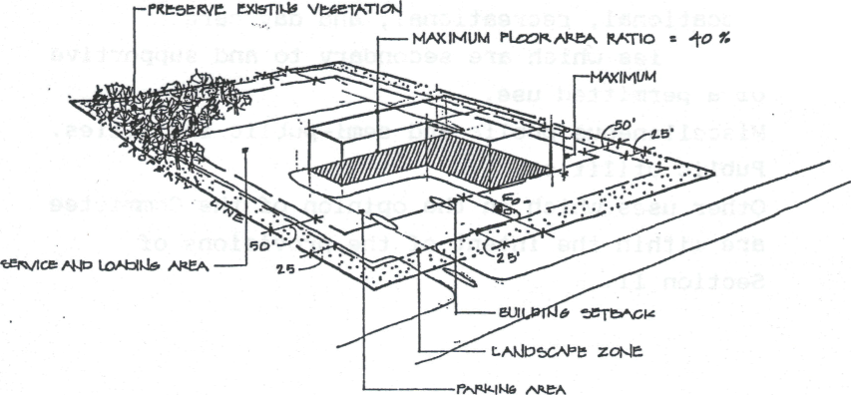
BUILDIM6 HPI*HT= 55'

(c) Landscape zones: Landscape buffer zones
adjacent to property lines in which no parking is permitted shall be as follows:
Front yard - 25 feet.
Side yard - 25 feet.
Rear yard - 10 feet.
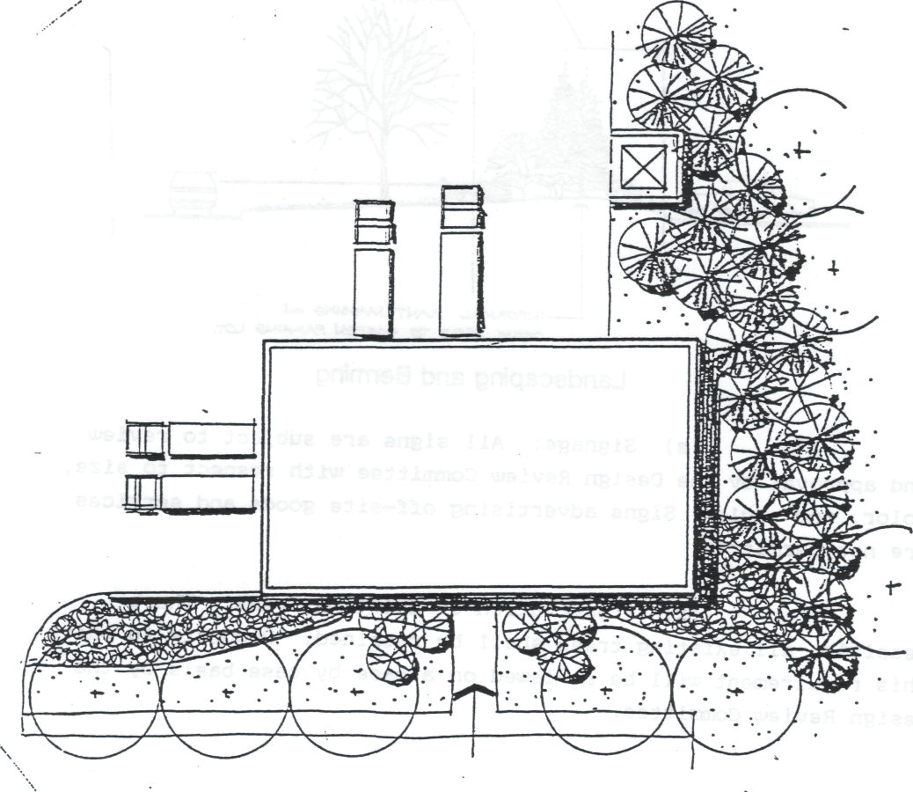

Screen Loading, Storage, and Service Areas
13
(d) Screening of Parking Lots, Loading, Storage, and Service Areas: Where visible from the street or adjacent Building Sites or properties, all parking lots shall be bermed and landscaped and all loading, storage, and service areas shall be screened by the use of berms, decorative fencing, plant material or a combination thereof.

V
lot.
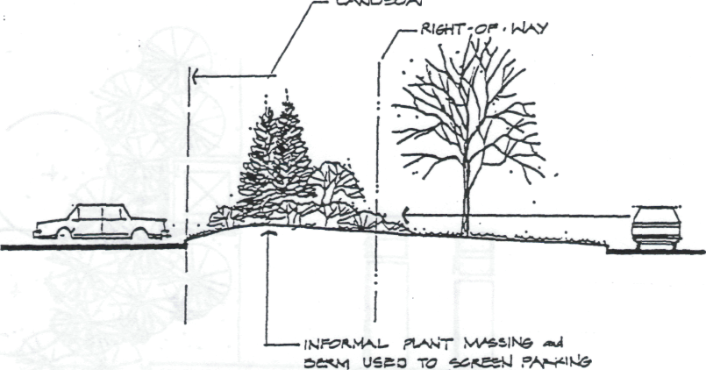

Landscaping and Berming
.
(e) Signage: All signs are subject to review
and approval by the Design Review Committee with respect to size, color, and style. Signs advertising off-site goods and services are not permitted.
(f) Preservation of Existing Trees: Where
feasible, all existing trees shall be retained. Requests to waive this requirement will be reviewed on a case by case basis by the Design Review Committee.

.

14

IN WITNESS WHEREOF, THE BOARD OF COUNTY COMMISSIONERS OF BLOUNT COUNTY, TENNESSEE has authorized this instrument to be signed by the County Executive for Blount County, and attested by the County Clerk, they having been duly authorized so to do at a duty called meeting held on the 2Slk day of January. 1991.
BLOUNT COUNTY, A POLITICAL SUBDIVISION OF THE STATE OF TENNESSEE

BY:
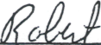

Robert Ramsey, Interim County Executive

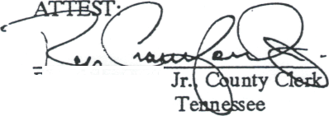
toy

Roy Crawford, Blount County,

AND

IN WITNESS WHEREOF, THE CITY COUNCIL OF THE CITY OF MARYVILLE, TENNESSEE has authorized this instrument to be signed by the Mayor for the City, and attested by the City Recorder, they having been duly authorized so to do at a duly called meeting held on the 6th day of November. 1990.

MARYVILLE, A MUNICIPAL CORPORATION OF THE STATE OF TENNESSEE
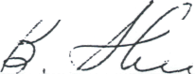
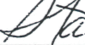
-^
BY:
Stanley D. Shields, Mayor City of MaryviUi^ Tennessee

ATTEST:

Debbie Caughron, City Recorder City of Maryville, Tennessee

STATE OF TENNESSEE) COUNTY OF BLOUNT)

Personally appeared before me, a Notary Public in and for said County, Bob Ramsey, with whom I am
personally acquainted, and who, upon oath, acknowledged himself to be the Interim County Executive of BLOUNT

COUNTY, Tennessee, the within named bargainer, a division of County government organized and existing under
the laws of the State of Tennessee, and that he as such County Executive, being authorized so to do, executed the
, within instrument bribe purposes therein contained by signing the name of the organization by himself as County
' Executive.
\

Personally appeared before me, a Notary Public in and for said County, Stanley O. Shields, with whom I am personally acquainted, an who upon oath, acknowledged himself to be the Mayor of the City of Maryville, Tennessee, the within named bargainer, an organization existing under the law of the State of Tennessee, and that he as Mayor, being authorized so to do, executed the within instrument for the purposes therein contained by signing the name of the organization by himself as Mayor.

Notary Public
4-
WITNESS MY HAND and Official Seal at office thisViday of
1992.
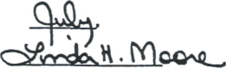

My Commiuion Expire*: )0" /"

